Professor of Philosophy created a site
In Sombor on the Internet to Learn Hegel
Author: Z. Vasiljevic | November 28, 2008. - 11:12
SOMBOR - Milos Rastovic, professor of philosophy, after several years of working in a school, came to the conclusion that students find it easier to follow the classes if they are able to learn through the Internet. That is why two years ago he began creating a special Website dedicated to the philosophy. The site is now open running, but he is still enriching it with new contents.

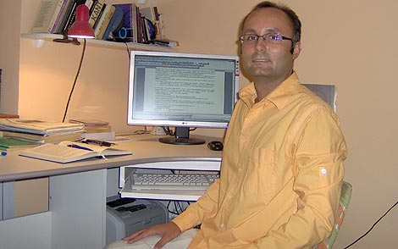

- At High Technical School in Sombor, I had the problem of how to make students interested in philosophy. Modern technology, primarily using the Internet provides plenty of opportunities for expansion of knowledge in all fields of science, and so I came to the idea to create a website dedicated to philosophy. My goal was to make philosophy and other similar disciplines accessible, interesting and popular - says professor Rastovic.
Rastovic explains that students now learn much easier because they can focus on the lecture in the class. On the other hand, they can check their knowledge through the Internet. Philosophy on the website is a way to solve the problem of the lack of quality textbooks.
On professor Rastovic website can be found all the information related to the teaching of philosophy. There is a students' page where they present their seminar papers, but also lectures of the professor during the entire school year with the literature and many other areas related to philosophy. Www.philosophymr.com site has versions both in Serbian and English. Professor Rastovic received compliments for his project from university professors from the United States and Great Britain. Zorica Kuburic, Professor at the University of Novi Sad Faculty of Philosophy, wrote in a column her impressions: "The site is excellent. It will be an example to my students. I’ll send one of them to you to practice.”
One of the classes in Technical High School where professor Rastovic teaches is IV/4, the field of computer science. They have philosophy two times a week.
- We study philosophy using only the site because it is easier than learning from books. The site is of the professor of the classroom - said student Branko Sedlar. Student Vladimir Popovic added that his knowledge of philosophy is good regardless of the fact that the students are in the vocational school.
- We have a textbook, but it is much easier to learn using the site. I have more affinity for technology than for the social sciences, and the site facilitates learning - says student Nikola Pilja.
A new way of learning
In the world 130 million students learn through the Internet.
- Learning via the Internet is a new way of learning in secondary schools in Serbia. I am in a technical school, and I presented the site to my colleagues, and I hope that they will start doing something similar - says Milos Rastovic.

Author: Z. Vasiljević | November 28, 2008.

