Editor „Дневник Војводина прес д.о.о.”, 21000 Нови Сад, Булевар ослобођења 81.
March 20, 2009
AMERICANS COMING TO SOMBOR BY THE WIRE

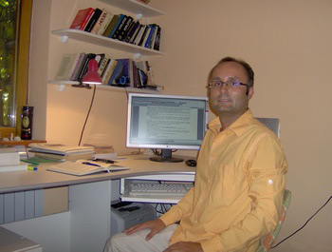
Milos Rastovic, professor of philosophy at Technical High School in Sombor, most recently, decided to embark on the Serbs’ ever so popular project—management. If he were to lobby an existing nonprofit organization or found his own, he would probably get a good funding. Thus, "on his own bread," and guided by the Kantian maxim that a person should have the courage to serve his own sense, he made a remarkable first website dedicated to those who are just entering the world of science and philosophy inquire.
- I managed primarily in order to make education more interesting for students, encouraging them to use their minds and modern technology, so that philosophy and its history could become approachable for them – explains Rastovic the idea of what went into making the specialized website.
- Learning through the Internet is something new in high schools in Serbia, and this is the only website dedicated to philosophy. It is created in an accessible way, and you can find all information about how to teach philosophy; seminar papers are presented on the student’s page, there are lectures and literature from the professor Rastovic throughout the school year, a gallery of philosophers, interesting facts—philosophical quizzes, games and jokes—the famous people who have studied philosophy and have received the Nobel Prize for literature or peace, what is the meaning of philosophy in today's society, useful philosophy links in Serbia and in the world in general and much more -- explains professor Rastovic who is inclined toward the Enlightenment.
One of the most popular webpages is the "Film and Philosophy" page, which was published in a newsletter on the prestigious website of the Britain Philosophical Society "Friedrich Nietzsche” in December 2006. Visitors to Rastovic’s website were many professors and students from American universities who wrote almost panegyric impressions of him.
The Internet has enabled teachers of philosophy to develop a methodological approach to student’s awareness in critical thinking; thus, the education process becomes a combination of Plato's Academy and Sammerhil. Such an approach can help people who will have enough wisdom to use their minds and critically and autonomously perceive reality. This wise, critical perception is a humanistic ideal in the development of the individual and society—Rastovic is convinced.
Address of this unique site is: www.philosophymr.com
M. MILJENOVIĆ
March 20, 2009

